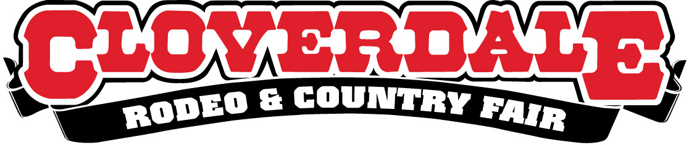

Outside Concession Application

Friday May 20, 2022 – Monday May 23, 2022

General Information:

Company Name:
Contact Person:
Address:
City: |  |  |  |  |  |  | Postal Code:
Phone – Work: |  |  |  |  | Home: |  |  |  | Cell:
Fax: |  |  |  | Email:

Concession Space Information (complete where applicable):

Frontage |  |  |  |  |  |  |  | Depth:
Number of Service Sides: |  |  |  |  | Booth Size - Height: |  |  |  |  | Width: |  |  |  | Length:
Size of Trailer Hitch: |  |  |  |  |  |  | Size of Awnings Open:
Size of Seating Area:
Total site size required:
Electrical Requirements: |  |  |  |  |  |  |  |  | Water Requirements:

Booth Space Lease Fees are $525 plus GST, i.e. $551.25 including taxes.

Booth space size is 10ft X 10ft booth outdoor.

License agreements will be sent to all successful applicants before April 26, 2022.
Unsuccessful applicants will also be notified at that time.

Please Return Your Application To:
Cloverdale Rodeo & Country Fair
6050A - 176 Street
Surrey BC V3S 4E7
Attention: James E King
Email: JamesEKing@telus.net
Fax: 604-576-0216

Application Deadline is March 31, 2022

Booth Type and Description:

Please attach a photograph:

Products Pricing:
Item | Price

History & References:
Please list previous concession experience:

Event: |  | Year: |  | Contact: |  | Phone:
Event: |  | Year: |  | Contact: |  | Phone:
Event: |  | Year: |  | Contact: |  | Phone:

Comments of Requests:

Note: If more space needed, please print extra copies of this sheet

