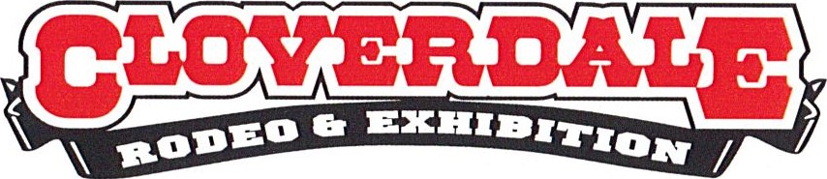

July 25, 2021

Rodeo Association's Statement Regarding Human Rights Complaint

The Cloverdale Rodeo and Exhibition Association have been made aware of a Human Rights Complaint and have received a copy of an appendix to that complaint. To be clear, the Association has not received a copy of the complaint itself.

The Association’s Board of Directors takes these allegations very seriously and is vigorously working to learn as much as possible. The Board will respond fully within the process determined by the Human Rights Tribunal.

It is important to note that as a result of an earlier Human Resources investigation (initiated by the Board) completed in February 2021, the Association has undertaken significant actions to ensure it is meeting the high standards expected of a community organization.

- The General Manager responsible was removed in February of this year
- A draft Respectful Workplace Policy has been developed
- A process for anonymous reporting of workplace concerns to an independent professional is included in that policy

Work is ongoing to address every recommendation.

"Throughout our history thousands of people, both young and old, have worked hard to make the Cloverdale Rodeo a proud community tradition," said Rich Kitos, Rodeo Chair and Vice President of the Association. "We want to ensure those employees and volunteers experience a respectful and inclusive environment in which each one of them is acknowledged for their valuable contribution."

Media Contact:

Mary Polak
C: 604-338-9969
E: mary@mapleleafstrategies.com

