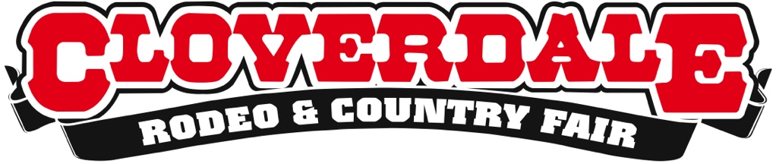

Cloverdale Fairgrounds operations being negotiated
A joint statement from the City of Surrey and
The Cloverdale Rodeo & Exhibition Association

July 13, 2021

The City of Surrey and the Lower Fraser Valley Exhibition Association announce an upcoming change to the operation of the Cloverdale Fairgrounds. The two parties are working on an agreement for the City to assume management of the Fairgrounds, allowing the Association to focus on one of BC’s most cherished, historical and longstanding events, the annual Cloverdale Rodeo and Country Fair. This transition will likely take several months. In the meantime, the Association will continue planning for the next Cloverdale Rodeo and Country Fair for May 20-23, 2022.

- end -

Media Inquiries:
Shannon Claypool, President - Cloverdale Rodeo & Exhibition Association
+1 (604) 970-6611 | sclaypool@shaw.ca

Lower Fraser Valley Exhibition Association Get Connected
Cloverdale Fairgrounds - 6050A-176th Street, Surrey, BC
604-576-9461 - cloverdalerodeo.com

