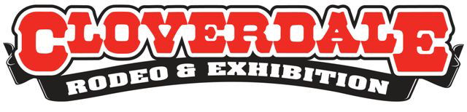
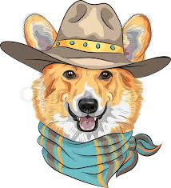

Cloverdale Corgi Release, Waiver & Indemnity Form
In the acceptance of my application and the permission to participate as an entrant or competitor in the, CLOVERDALE RODEO CORGI RACES- MONDAY, MAY 18, 2020
I HEREBY RELEASE, WAIVE AND FOREVER DISCHARGE the Cloverdale Rodeo & Exhibition Association, and all other officials, contractors, representatives OF AND FROM ALL claims, demands, damages, costs, expenses, actions and causes of action, whether in law or equity, in respect of death, injury, loss or damage to my person or property HOWSOEVER CAUSED, arising or to arise by reason of my participation in the said event as a participant, whether prior to, during or subsequent to the event and NOTHWITHSTANDING that same may be contributed to or occasioned by the negligence of any of the aforesaid.
I FURTHER HERBY UNDERTAKE to HOLD AND SAVE HARMLESS and AGREE TO INDEMNIFY all of the aforesaid from and against any and all liability incurred by and or all of them arising as a result of, or in any way connected with my dog’s participation in the said event.
BY SUBMITTING this ENTRY, I ACKNOWLEDGE HAVING READ, UNDERSTOOD AND AGREED to the above WAIVER, RELEASE, and INDEMNITY. I WARRANT that my dog is physically fit to participate in this event.

Print Name: ____________________________ Signature: ___________________________
Dog’s Name: ____________________________ Date: ______________________________

