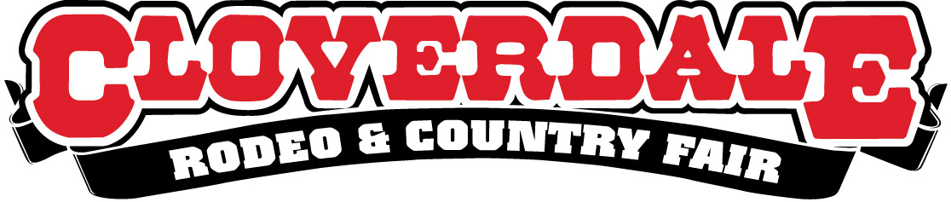

ELECTRICAL SERVICES (ADVANCE) ORDER FORM 2020
ELECTRICAL:
120 Volt / 15 Amp / Single Phase |  | X 90.00 =
120 Volt / 30 Amp / Single Phase |  | X 110.00 =
208 Volt / 30 Amp / Single Phase |  | X 180.00 =
208 Volt / 50 Amp / Single Phase |  | X 210.00 =
208 Volt /100 Amp/ Three Phase |  | X 315.00 =
Total (includes all applicable taxes) =

(All vendors must supply their own cord/plug ends)
(Above pricing is for ordering at time of returning your license agreement and must be paid for when you send in your license agreement)

Area: ☐ Food Concessions ☐ Outdoor Exhibitor

Water and Sewer Connections Required (Food concessions only) ☐ Yes ☐ No

Company Name
Contact
Phone

METHOD OF PAYMENT: ☐ Cheque (enclosed) ☐ Visa ☐ MasterCard

Card No. |  |  | Expiry Date:
Name of cardholder (please print) Signature

OR Make your cheque payable to:
Cloverdale Rodeo & Exhibition Association
6050A 176 Street, Surrey, BC V3S 4E7
Fax: (604) 576-0216
Return this order form & PAYMENT with your license agreement

